For more information about other Microsoft customer successes, please visit: www.microsoft.com/casestudies
Customer: headON Communication
Website: www.headon.at
Customer Size: 16 employees
Country or Region: Austria
Industry: Durable goods merchant wholesalers—Electronic merchandise wholesalers; Professional services

Customer Profile
headON Communication distributes high-quality headsets and communications equipment and offers communications services to resellers and business customers in Austria.

Software and Services
- Microsoft Dynamics
- Microsoft Dynamics CRM
- Microsoft Dynamics NAV
- Microsoft Server Product Portfolio
- Microsoft Exchange Server
- Microsoft SharePoint Server
- Microsoft SQL Server
Technologies
- Connector for Microsoft Dynamics
Microsoft Dynamics
Customer Solution Case Study
Electronics Distributor Connects Systems to Simplify Operations, Enable Executive Control
“By using Microsoft Dynamics NAV integrated with Microsoft Dynamics CRM, our financial management, customer engagement, and performance management are extremely effective in maintaining our competitive advantage and leading market share.”
Rene Horvath, CEO, headON Communication

Business Needs
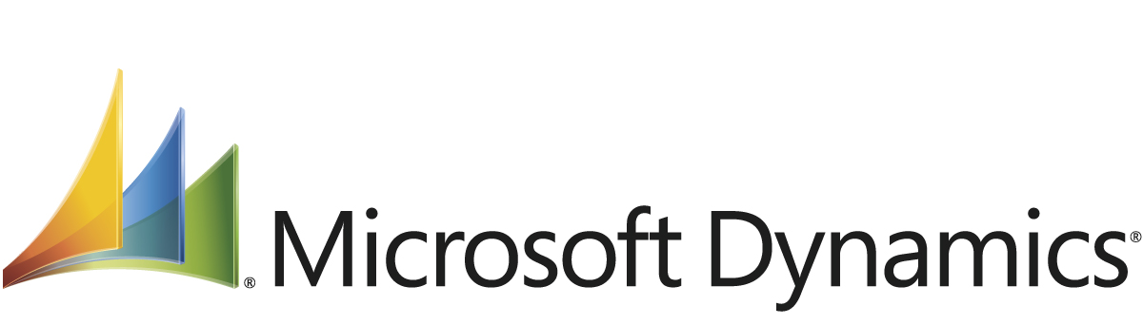

Based in Vienna, Austria, headON Communication distributes leading brands of headsets to approximately 5,000 customers in Austria. The company’s market share in the industry is close to 80 percent. In addition, headON Communication provides telephony equipment, private branch exchanges, and voice-over-IP products. The company’s 16 employees produce annual revenue of €9 million (approximately U.S.$12.08 million).

Following its inception in 2003, headON Communication used an enterprise resource planning (ERP) system from GDI to help manage finances and operations. This software had some shortcomings that the company hoped to overcome. Rene Horvath, CEO of headON Communication, explains, “The cost and pricing information in our system was occasionally unreliable. Without any integration to the warehouse system, it was unable to reflect the value of our inventory or inform us of the length of time products were on the shelves.”

In addition, sales and service employees needed to consult the finance team to verify what customers owed, so they were unable to give a customer this information in the same call. Finally, headON Communication lacked a reliable way to verify that it had indeed sold products that customers returned under warranty for repair or replacement; because of this, headON Communication incurred losses from unfounded warranty claims it needed to honor. The ERP system lacked support for end-to-end tracking of individual products by their serial numbers. Says Horvath, “Whatever decisions we had to make, from strategic issues to resolving a simple detail question, we always needed to research several systems.”

Solution
headON Communication already had implemented Microsoft Dynamics CRM as its customer relationship management system and almost everybody in the company used the solution. “We had a very good experience with Microsoft Dynamics CRM,” explains Horvath. “The solution, which is very easy to use, is the main business tool for our people who support customers in sales and service delivery. We wanted the new ERP system to be able to integrate with Microsoft Dynamics CRM to help close our informational gaps and simplify the way we worked.” The company also used Microsoft SharePoint Server for information exchange and collaboration, Microsoft Exchange Server for communications, and Microsoft SQL Server as its business database. It made best sense to extend the same technology environment.

At an industry trade show, Horvath learned about Microsoft Dynamics NAV and felt that this ERP system was a good fit for the company’s requirements. The company engaged local Microsoft partners, STANDARD:IT Solutions and MBS Training, to perform the implementation and user familiarization; STANDARD:IT Solutions already had successfully implemented Microsoft Dynamics CRM. User adoption was immediate, with only minimal need for training. Says Horvath, “The solution is extremely intuitive and comfortable to work with. Within one day, everybody learned how to perform many of the more frequent tasks and locate information.”

Today, Microsoft Dynamics NAV connects and supports all of headON Communication’s business processes, including financials, warehouse management, and business planning and performance management. By using the Connector for Microsoft Dynamics, headON Communication integrated Microsoft Dynamics NAV with Microsoft Dynamics CRM. This connection makes it possible to share information recorded in one system throughout the company’s business infrastructure, making it directly available to all employees. In addition, headON Communication uses the Microsoft Dynamics RoleTailored experience in Microsoft Dynamics NAV to simplify employees’ work by serving up the most critical information and capabilities and removing distractions. This capability is particularly relevant for making financial information available.

Benefits
By integrating Microsoft Dynamics NAV with Microsoft Dynamics CRM, as well as the company’s other key systems, headON Communication owns a reliable, flexible infrastructure to move the business forward. Horvath comments, “With Microsoft Dynamics NAV, we can better achieve our goals and be nimble managers of our growth. Microsoft is a long-term technology provider with a strong commitment to further develop the ERP system, which lets us maintain the value of our investment.”

Engage More Effectively with Customers
Through the integration of the ERP system and the customer relationship management system, headON Communication’s employees can more easily serve customers. For instance, an employee can review the serial number tracking of individual products in the ERP system, easily determine whether a customer’s repair request falls under warranty or not, and take the right next steps. Savings generated by no longer honoring unfounded warranty claims amount to close to €5,000 (approximately U.S.$6,890). Geographical and other information from the ERP system also serves to structure successful campaigns managed with the customer relationship management system to market interesting products to those customers who are most likely to see their value. “With the support from Microsoft Dynamics NAV, we are growing revenue by up to 25 percent per year without adding head count,” comments Horvath.

In addition, the company has improved customer self-service by integrating Microsoft Dynamics NAV, Microsoft Dynamics CRM, and SharePoint Server. As Horvath explains, “Customers appreciate the ability to review their orders and shipping statuses, and other details, by logging on to our website at any time without having to call or send an email message. In turn, that means fewer calls and messages to our sales and service team members, who can be more proactive in working with customers.”

Simplify Business Operations
With Microsoft Dynamics NAV, headON Communication runs a more efficient operation. Says Horvath, “We now have much better control in our inventory management. We were able to double the speed of inventory turns and almost entirely eliminate losses through inventory devalorization.” Automated inventory replenishment, using inventory levels that the ERP system suggests, also offers significant advantages. “By automating our ordering, we not only save the many hours of work that employees previously spent on establishing the proper order volumes, but we also can purchase at better cost and consolidate deliveries,” adds Horvath. “By using wireless scanners connected to Microsoft Dynamics NAV, we generated new efficiencies in our logistics center and were able to reassign one full-time employee.” In addition, the monthly reports to inform suppliers of the company’s sales are now automatic, no longer requiring manual collation of data.

Manage for Optimal Business Performance
From detailed tasks in financial management to executive decision making, headON Communication managers use the integrated ERP system and the customer relationship management system to strengthen the company’s competitive standing in the Austrian market and take control of the business. “As the CEO, with Microsoft Dynamics NAV, I have much better visibility into our day-to-day and long-term performance compared to benchmarks we established and can easily initiate course corrections,” says Horvath. “We can respond immediately to changes in the market, which often take place quickly. At the same time, the solution closely reflects the needs of employees who need to access certain financial information. It takes minimal effort, for example, to make small changes in the RoleTailored experience to ensure that employees find the details they need to be aware of. The solution is as flexible as it is easy to adjust.”

