For more information about other Microsoft customer successes, please visit: www.microsoft.com/casestudies
Customer: D’Arrigo Brothers Company of Massachusetts
Website: darrigoma.com
Customer Size: 25 employees
Country or Region: United States
Industry: Wholesale and distribution—Nondurable goods merchant wholesalers—Grocery and related products wholesalers
Partner: Columbus IT
Website: www.columbusit.com

Customer Profile
D’Arrigo Brothers Company of Massachusetts is a terminal market wholesaler of produce.

Software and Services
- Microsoft Dynamics
- Microsoft Dynamics NAV
Microsoft Dynamics
Customer Solution Case Study
 | 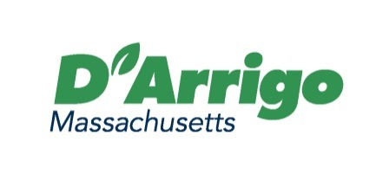 |  | Terminal Market Produce Distributor Takes Charge of Operations with ERP Software
“By using Microsoft Dynamics NAV, we can see what’s going on in real time with any given commodity, lot, or PO. At any time, we know what we bought, what we sold, and what our profit is.”
Peter D’Arrigo, President, D’Arrigo Brothers Company of Massachusetts

Business Needs
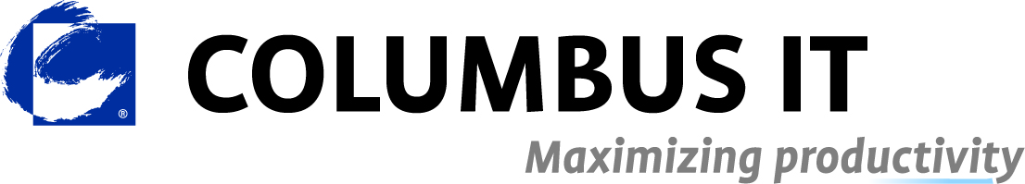 |  |  | 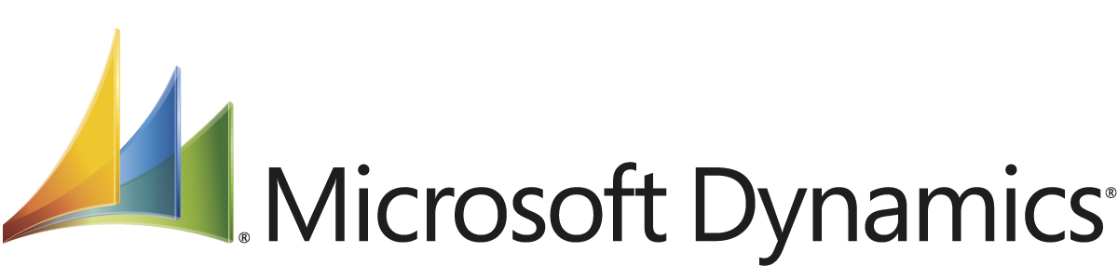

D’Arrigo Brothers Company of Massachusetts is a terminal market produce distributor working out of the New England Produce Center in Chelsea, Massachusetts. The company has 25 employees and provides a full assortment of produce to customers that range from grocery store chains to restaurants and small, one-person grocers.

For D’Arrigo Brothers, operations had been largely manual. “When an order came in, employees would write a pick ticket for that order, pick those items, and then, sometime later in the day, subtract those items from a list of our inventory,” says Peter D’Arrigo, President of D’Arrigo Brothers Company of Massachusetts. “We would then reenter the sales information into the accounts receivables of our accounting software.” Consequently, the company lacked real-time insight into inventory and could run into issues of underselling or overselling. The manual processes could also lead to error and consumed the time of staff, taking about one and a half hours out of each salesperson’s day and an hour per day for each person in accounting.

Manual processes weren’t the only pressing challenge, however. Says D’Arrigo, “Our accounting software was developed in-house and based on Linux, which we felt wasn’t the future of technology, and it was more than 20 years old. Customizing it to meet our needs was extremely difficult, and we weren’t sure if we could support it much longer.”

To eliminate manual processes and help ensure the future of the company, D’Arrigo began to look for an enterprise resource planning (ERP) solution that would span both accounting and operations. He also sought one that would be easy to support and that could grow and change with the business.

Solution
After considering several solutions, D’Arrigo Brothers chose Microsoft Dynamics NAV and worked with Microsoft Gold Certified Partner Columbus IT to drive the implementation forward. Explains D’Arrigo, “We looked at Produce Pro, which was a good solution, but it wouldn’t get us away from Linux. Then we compared a Famous Software solution and Microsoft Dynamics NAV; of those two, the Microsoft solution was easier to update, change, and work with. In addition, we felt the solution was future-proof—Microsoft would be there for years.”

Working with Columbus IT, D’Arrigo Brothers initially went live with the solution in 2005. Since then, the company has continued to work with Columbus IT to keep the solution up-to-date, undergoing two upgrades and making several key modifications to support changing business requirements.

With Microsoft Dynamics NAV in place, D’Arrigo Brothers supports its operation with a single solution, eliminating many of the manual processes the company relied on before. By using the ERP software, employees enter purchase orders (POs) as they come in. The system then automatically produces a delivery ticket and subtracts from the available inventory in real time. After that, employees can ship the produce and use the system to produce an invoice for the customer. And as sales staff buy produce for reselling, they can enter it into the system as well.

In supporting the buying and selling of produce, D’Arrigo Brothers staff makes particular use of a terminal market screen that comes as part of Columbus IT’s vertical market solution for food distributors. The terminal market screen provides comprehensive insight into any given lot, including information such as costs; where the produce came from; and where it will be delivered, providing much-needed traceability for food safety regulations. By using this functionality, D’Arrigo Brothers staff can quickly find a lot that best fits a customer’s need—for example, by looking into lots based on price, brand, or even freshness.

By working with Columbus IT, D’Arrigo Brothers also benefits from many other features that Columbus IT provides as part of its food distribution solution. Features include the ability to track the expiration dates of produce and handle the buyback of produce that customers were unable to sell so that D’Arrigo Brothers can then sell that produce on consignment at a discounted rate. With this tailored feature set, D’Arrigo Brothers can also account for the repacking of bulk produce into different-sized packages for resale. The company can also account for the splitting of shipping costs across multiple POs that are a part of a single load.

Benefits
With Microsoft Dynamics NAV, D’Arrigo Brothers Company of Massachusetts has a single, integrated solution that spans both accounting and operations. With the ERP system in place, the company has gained real-time insight and control over its business, helping to improve productivity, profitability, and customer relationships.

Gain Real-Time Insight into Operations, Improve Profitability
Now, as sales staff buy and sell produce, the related information remains up-to-date, enabling D’Arrigo Brothers to understand and react to changes in the business. Says D’Arrigo, “By using Microsoft Dynamics NAV, we can see what’s going on in real time with any given commodity, lot, or PO. At any time, we know what we bought, what we sold, and what our profit is.”

In terms of the company’s profitability, D’Arrigo goes on to note that, “Before we make a sale, we know exactly what the margin will be and how that fits into our business plan, which has undoubtedly made us a more profitable business.”

Save 80 Hours a Week, Boost Morale
Eliminating manual processes, D’Arrigo Brothers staff in sales and accounting now save considerable time. “Because we have eliminated data reentry by using Microsoft Dynamics NAV, sales staff are saving one and a half hours a day and accounting staff are saving an hour a day—all while our data has become more accurate,” says D’Arrigo. “And now, we can spend that time talking to customers and tracking down new customers.” Across the company’s sales staff and accountants, this comes to a timesavings of 80 hours a week that staff members can now apply to more value-added tasks.

This improvement in productivity has had an impact on company morale as well. Says D’Arrigo, “Because we don’t have to rekey data, we are less prone to make errors and we have taken a lot of pressure off the people in sales and accounting, which has had a positive effect on employee morale.”

Improve Customer Relationships
Maintaining a streamlined operation by using Microsoft Dynamics NAV has had its positive impact on customer relationships as well. “With Microsoft Dynamics NAV and Columbus IT’s terminal market solution, we are much more responsive to customers and we’re able to get them through the buying process much quicker,” says D’Arrigo. “Furthermore, we’re not running into the issues of underselling or overselling produce; if we tell a customer we have the product they want in the quantity they want, it’s because we do. Overall, we have improved our relationships with customers tremendously.”

