For more information about other Microsoft customer successes, please visit: www.microsoft.com/casestudies
Customer: Ahmad Tea
Website: www.ahmadtea.com
Customer Size: 70 employees in the United Kingdom
Country or Region: United Kingdom
Industry: Manufacturing—Consumer goods manufacturing; Wholesale and distribution—Consumer goods distribution
Partner: Innoware

Customer Profile
Ahmad Tea is U.K.-based tea company that provides its quality tea products to more than 70 countries.

Software and Services
- Microsoft Dynamics
- Microsoft Dynamics NAV
Microsoft Dynamics
Customer Solution Case Study
Global Tea Company Supports Varied Operations with Flexible, Adaptable ERP System
“For 10 years, we have been able to specify what we want Microsoft Dynamics NAV to do and then roll out new functionality or customize it to meet those needs.”
Peter Jacob, Corporate IT Manager, Ahmad Tea

Business Needs
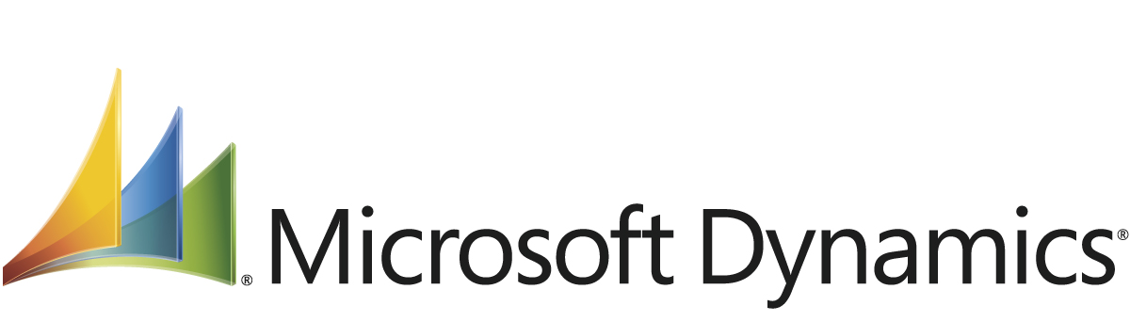

Ahmad Tea is a family business with three generations of tea knowledge. The company has 70 employees in the United Kingdom and a broader team worldwide with operations in Sri Lanka, the United Arab Emirates, Russia, the Ukraine, and China. The company prides itself on the quality of its tea and works to source the finest teas from around the world, which it then blends, packages, and ships to customers in 70 countries on six continents.

To run an effective global business, Ahmad Tea established its operations to serve largely different, yet complementary, business functions. For example, the company’s U.K. office acts as corporate headquarters, a central warehouse, and a factory and oversees the Sri Lankan operation, while its Sri Lankan facility mainly deals in the purchasing and distribution of tea.

Because its business units are unique and operate largely independently, Ahmad Tea made the strategic decision in 2001 to switch from a Sage accounting solution to Microsoft Dynamics NAV for its comprehensive enterprise resource planning (ERP) capabilities that could support the needs of its separate business units. Finding the ERP solution’s flexibility to meet each operation’s needs particularly beneficial, Ahmad Tea has since undergone a range of changes to each deployment to drive ongoing improvements to the business. Peter Jacob, Corporate IT Manager at Ahmad Tea, says, “We began using Microsoft Dynamics NAV for accounting and basic stock control and then expanded our Sri Lankan deployment with the manufacturing capabilities and our U.K. deployment with the warehousing capabilities. Now, 10 years later, we continue to find ways that the solution can have a positive impact on our business, either by customizing it or by deploying more capabilities.”

Solution
To support its deployment of Microsoft Dynamics NAV, Ahmad Tea works closely with Microsoft partner Innoware. Ahmad Tea has Microsoft Dynamics NAV at its London, Dubai, and Sri Lanka facilities and is currently undergoing a new deployment at its Russian operation. Across the company, 35 employees use the ERP software every day. These employees span departments including purchasing and planning, sales, warehousing, and accounting. In supporting its multinational organization, the company makes particular use of the multilanguage and multicurrency capabilities of Microsoft Dynamics NAV, for example, to produce sales documents in Russian or to track sales and purchase transactions in British pounds, U.S. dollars, and euros.

While all operations use the financial management capabilities of Microsoft Dynamics NAV including general ledger, accounts payable, and accounts receivable, the business units’ other use of the solution’s functionality differs greatly. Within the last few years, for example, the company has expanded its Sri Lankan deployment to include the manufacturing capabilities of Microsoft Dynamics NAV. Explaining the company’s use of this functionality, Jacob says, “By using the manufacturing capabilities of Microsoft Dynamics NAV, we’ve been able to track the core components that go into our tea products, including flavoring, tea bag paper, and the tea itself.

The Russian operation, on the other hand, will use Microsoft Dynamics NAV to facilitate receiving tea from Sri Lanka and China, packing the tea, and then shipping the tea within Russia. And at the company’s U.K. office, which functions as the corporate headquarters and a manufacturing facility serving the United Kingdom and European gift markets, employees use Microsoft Dynamics NAV for inventory and warehouse control of the U.K. factory and to oversee the Sri Lankan operation.

Ahmad Tea has also recently deployed the business analytics capabilities of Microsoft Dynamics NAV at the corporate level. These capabilities draw on several of the company’s databases that the ERP solution runs on, which helps provide a 360-degree view of the business. Ahmad Tea has set up more than 10 reports that provide a snapshot of key customers or groups of customers. In these reports, employees can see, for example, what products customers are buying and customer sales figures versus performance from a year before. “All those reports are available at the touch of a button, whereas, before, we had to pull and consolidate that information from our separate systems,” remarks Jacob. “And better yet, the reporting capabilities are easy to use, so even those people who aren’t particularly familiar with the finer points of Microsoft Dynamics NAV can pull the information they need.”

Benefits
Ahmad Tea has found Microsoft Dynamics NAV to be the right fit for its various business units. Says Jacob, “With Microsoft Dynamics NAV, we can continue to roll out solution enhancements to each of our operations, driving ongoing improvements and supporting our ongoing growth as a company.”

Streamlined Manufacturing Operations
By using Microsoft Dynamics NAV, employees at Ahmad Tea have the ability to maintain an efficient operation. Reflecting on the recent deployment of the solution’s manufacturing capabilities, Jacob says, “Before deploying the manufacturing capabilities of Microsoft Dynamics NAV, we had to aggregate all the information regarding the components of our items and our inventory. Now, all that information is available within the system. We’re saving considerable time and are able to ensure that we produce the right amount of product, have the right amount of product in stock, and can give more accurate lead-time information to our customers.”

Adaptability and Robustness for More Than a Decade of Change
With a flexible, customizable solution, Ahmad Tea is also able to quickly react to business changes as well as changes in the market. First using the solution for accounting and stock control, Ahmad Tea now uses it for manufacturing, warehousing, and business analytics. “What we particularly like about Microsoft Dynamics NAV is its flexibility, enabling us to change a process within the solution to reflect a change in our business very quickly,” says Jacob. “For 10 years, we have been able to specify what we want Microsoft Dynamics NAV to do and then roll out new functionality or customize it to meet those needs.”

Cost-Effective Growth
Entering 20 new markets over the past decade, Ahmad Tea can continue to rely on Microsoft Dynamics NAV to support the company’s growth. At the same time, the company has been able to tailor the solution to its needs, driving the ongoing improvements it needs to control costs while expanding. Says Jacob, “As we have expanded the business to sell to 20 more countries over the last 10 years and introduced a wider range of tea products, Microsoft Dynamics NAV has played a significant part in supporting that expansion cost-effectively.”

